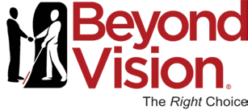

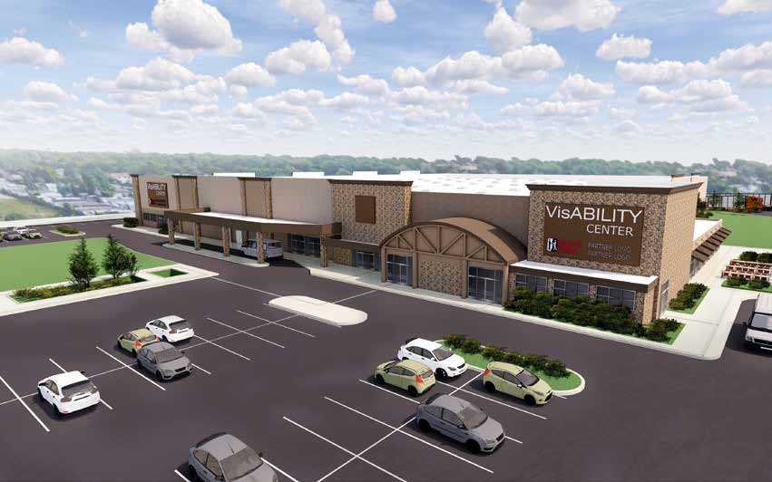
Future Home of the VisABILITY Center Campus

2019 Annual Report

Beyond Vision | 414-778-5800 | 5316 West State Street, Milwaukee, WI 53208 | www.beyondvision.com

Dear Friends of Beyond Vision,

The year of progress for Beyond Vision can be summed up this way…#MissionFirst. More than a decade ago, our leadership team embraced the philosophy that putting the mission first should drive every decision we make. We continually ask ourselves if we are making the best decision for the mission, ahead of personal or departmental priorities. If so, we are making the right decision. Years later that simple yet powerful philosophy is now reaping rewards in the form of growth. We are seeing growth in our jobs, our culture, computer accessibility, competitive salaries, the Board of Directors, and our fiscal health. This is no accident. Additionally, a dedicated Board and a strong, persistent leadership team lays the foundation for this growth. I am blessed to have both.

The most important measure of success is growing our mission. We’re reaching record levels of employment within all sectors of the company: from the Commercial Manufacturing shop floor, to the Customer Care Center, to our Government Products business unit, and to our eight remote distribution Base Supply Centers. Having successfully launched a new fully accessible ERP system in our Milwaukee operation, we now have 100% computer software accessibility for every position. This change in technology allows us to hire and promote any deserving sighted or mission employee to any role.

Our culture continues to grow healthier. Employees in all areas of the company have a strong emotional engagement to growing the mission. We center ourselves around Servant Leadership principles which are baked into the corporate Values and part of every employee’s annual review. The concept that leaders are focused on serving their staff to help them achieve their best now permeates the entire culture. Our employees and customers can feel it when they walk through the building.

Our leadership team also continues to rally around a simple yet powerful metaphor we call the “Runway.” Beyond Vision is a “Runway...a place to land and a place to take off in your career.” A person may ‘take off’ inside Beyond Vision or they
may choose to "take off' elsewhere in another company. Either way, we assist our employees to achieve their career aspirations. We call it a "win" when someone achieves upward mobility inside or outside the company. This #MissionFirst focus separates and defines us.

In July we instituted a formal job definition system. Most of our hourly employees received a pay increase adjustment to insure our pay is market competitive throughout the entire company. A similar analysis is about to get underway for our salaried positions. We’ve done this to support our assertion that, as I like to say, “This is not your grandfather’s sheltered workshop.” Said another way, "Beyond Vision is a competitive and integrated employer with the mission of providing career opportunities for people with vision loss."

The good news is we are experiencing this growth. The opportunity is we have run out of physical space. As a result, we've leased additional manufacturing space as a short-term solution to support the continued expansion of our newly formed Government Products group. The long-term solution is to create the VisABILITY Center campus. In June, with our Board’s full support, we successfully purchased a former regional Sam’s Club facility with plans to renovate it and move our entire Milwaukee operations there. The new campus will provide Beyond Vision space to continue growing its mission for the foreseeable future.

We also plan to invite all other non-profit service providers within the vision loss community to join us at the new VisABILITY Center campus. This co-location model will broaden our shared mission by creating a one-stop-shop for people experiencing vision loss. Together, we can give them the support they need to live a full life; so their vision loss does not prevent them from pursuing their dreams.

Heavily dependent on fundraising, our sister non-profit service providers experience a tremendous and continuous financial struggle, which causes them to not be able to offer the programing and services they like to. They all have hopes of adding more to their existing services and training, however, their budget sometimes won’t allow such expansion. The result is a continuous struggle to optimize

services offered within budget constraints. The VisAbility Center co-location concept will benefit the larger mission through significant operational cost savings across shared resources such as facilities maintenance, security, and perhaps computer systems. It makes no sense for these resources to be duplicated across the different non-profit entities. There’s little doubt co-location will lead to much better collaboration and mutual success while providing more value to the community we serve.

We are engaged in discussions with eye health providers about co-location. I’ve shared our dream with ophthalmologist and optometrist eye health professionals in the region at length. They absolutely love the concept. They see the value in being able to refer their patients to a single location for help and resources based on their individual needs.

Exciting times for Beyond Vision without a doubt! It’s all made possible by holding on tight to that modest yet potent philosophy. #MissionFirst
Volunteer Board of Directors

Thomas E. Arenberg, Chairman Emeritus
Accenture (Retired)

Shawn Duffy, C.P.A.
Controller, WTC Machinery

John Emanuel
Senior Counsel, Husch Blackwell LLP (Retired)
William Hughes, Chairman
USAFR (Retired)
Attorney, Partner, Husch Blackwell LLP
Eric D. Isbister, Secretary
CEO, GenMet Corporation

Danita Jackson
Intake Specialist, Disability Rights Wisconsin

James Kerlin
President & CEO, Beyond Vision

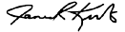
Jim Kerlin,
President &
Chief Executive Officer

William Hughes, Chairman of the Board of Directors

Paul E. Lima
Major General, U.S. Army (Retired)

Burton Metz
Vice President, Wangard Partners

Tom O'Connell
CEO, Tank Holding Corp./Snyder Industries
(Retired)

Jeffrey Alan Peil
Solutions Development Lead, Ascension Information Services

Eric Schumann
Potala Company (Retired)

Art Wasserman, J.D., PhD, M.B.A.
Rhodes Scholar
Corporate Division General Manager College Dean,
Attorney (Retired)

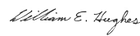
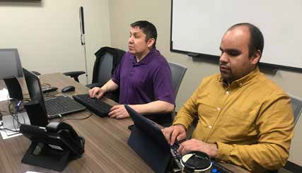
Tony Creapeau, IT Technician, and Israel Cazares-Zurita, Accessibility Coordinator, perform accessibility testing using a variety of technology.

A Future Built on Blind Ambition Becomes a Reality
The Blind Ambition Capital Campaign

Beyond Vision's current facilities limit the growth of its mission to provide meaningful and sustainable employment
for people with vision loss.

Beyond Vision is choked for space as it continues to market its manufacturing, assembly and packaging, customer care center and business products services to a broad base of local, state and national customers.

Current facilities have limited storage, no loading docks and most critical, a lack of fire protection. The cost of necessary renovations and expansion far outweigh the value of the current properties.

It is time to expand Beyond Vision facilities.

Beyond Vision will build a state-of-the-art manufacturing and administrative campus in West Allis, Wisconsin to broaden its own capabilities and mission as well as invite co-location of other organizations serving people with vision loss.

Beyond Vision is forming unique partnerships to create one of the first co-located vision loss advocacy, education
and employment centers in the country.
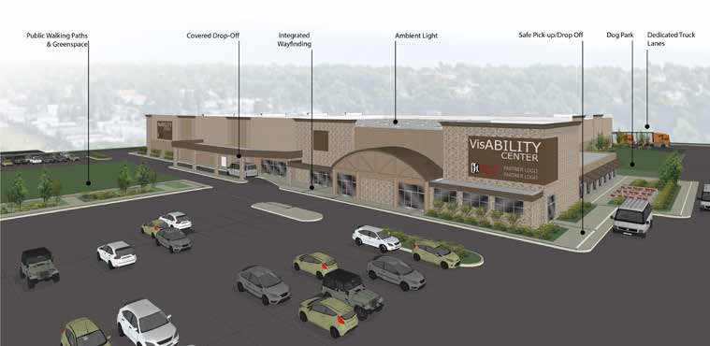

The new Beyond Vision campus will be one of the first in the nation to provide comprehensive services to individuals and families impacted by vision loss. We will use a proven,
collaborative model, which combines co-located service providers in one easily accessible location.

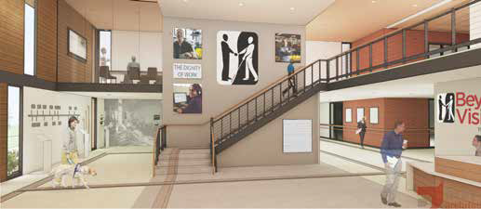
The welcoming and totally accessible lobby features an historical timeline of
employment and services for people with vision loss.

The entire facility will be completely low vision friendly with aids such as:
- Universal design throughout interior spaces
- Textured flooring for easy navigation
- Ambient lighting for those with low vision
- Braille signage and audio navigation aids throughout the building
- Landscaping will feature a public space for neighborhood inclusion and a scent garden
- Wisconsin Lions Dog Park for guide dogs on the campus
- A wellness center featuring adapted workout machines tailored for people with vision loss or blindness

The Beyond Vision Campus will offer co-location opportunities to other organizations serving people with vision loss, organizations such as the Blinded Veterans of Wisconsin, the state of Wisconsin Office of Blind Vocational Instruction as well as providers of eye health, literacy and rehabilitation and advocacy groups.

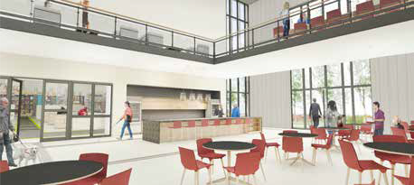
The $19 million project will be centrally located with
convenient access to public transportation.

Financial support for the campus will utilize a combination of public and private funding with major foundations and individuals already committed to the project goal.

The large capacity meeting/lunchroom will be a place for employees and co- location visitors to mix and mingle. When possible, the room will be available to organizations serving the vision loss community for special events and meetings.
You can help.
To learn more, contact Barbara Velez, barbara.velez@yahoo.com

50%
Mission Ratio:

105 Employees
53 Employees who are blind 52 Employees who are sighted All working side-by-side.

91,481
Blind Paid
Working Hours

90%
Percentage Blind
Direct Labor

$26,904,688
Revenues
Our Mission: Grow by being a valued partner to customers,
suppliers, and the community while operating as a fiscally responsible enterprise.

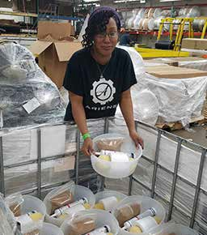

"This promotion is a huge accomplishment for me and I'm very thankful."

-Ericka Silas, Team Lead

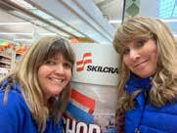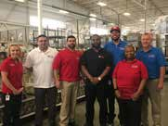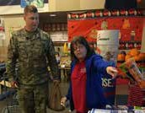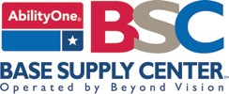

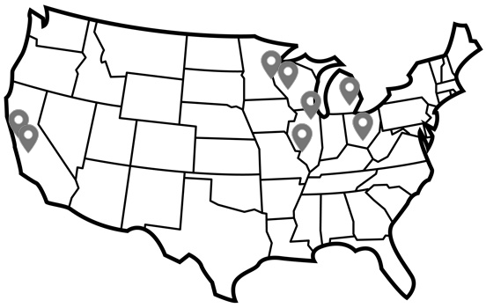
934th Airlift Wing -
Minneapolis, MN
- Coast Guard Island -
Alameda, CA
- Defense Supply Center -
Columbus, OH
- Fort McCoy -
Fort McCoy, WI
- Naval Station Great Lakes - Great Lakes, IL
- NASA Ames Research Center -
Moffett Field, CA
- Scott Air Force Base - Scott AFB, IL
- TACOM - Detroit Arsenal -
Warren, MI

Our mission extends outside the state of Wisconsin. We provide employment opportunities for people who are blind or visually impaired across the USA by operating Base Supply Centers on Federal installations to serve our military with supplies and SKILCRAFT® products. These products include the privacy filters, floor mats, socket sets and sit-stand desks we produce at Beyond Vision.

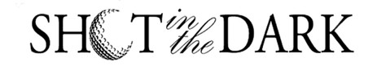
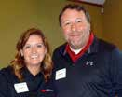
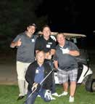
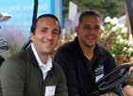
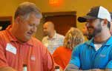
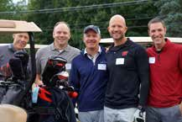
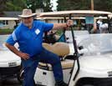
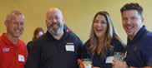
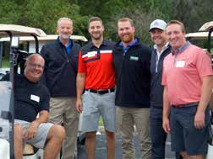
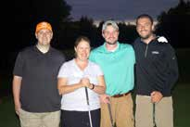
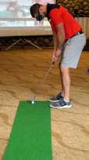
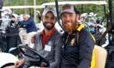
Golfers at our signature fundraising event gathered at Silver Spring Golf Club in September to support our job training programs. This event is a one-of-a-kind experience with half the course played in the dark.

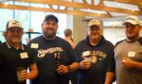

Another great year with the best attendance on record and a wonderful time.
All in support of our mission.

Hard Work Pays Off

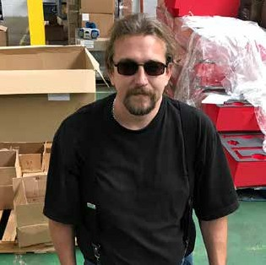
Finding and maintaining meaningful employment can be difficult for people living with vision loss. One person who understands this is Jedidiah Moss.

Jed was born with a rare degenerative eye condition, making him legally blind. While living in Marinette, WI, Jed struggled to find a consistent job. He had bounced around trying to get by on disability insurance and working for various restaurants and hotels in the Marinette area.
Although Jed possesses an incredible attitude and work ethic, he says finding a steady job was a struggle.

“Living with a vision impairment, it is difficult to find a good job. I think people often take those opportunities for granted.”

Jed heard about Beyond Vision from his friend and fellow alumni of the Wisconsin Center for the Blind and Visually Impaired, Rueben Rodriguez, a current Beyond Vision employee. Upon learning about the job opportunity at Beyond Vision, Jed made the difficult decision to move from Marinette to Milwaukee and began working with us in January of 2019.

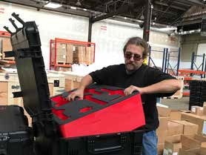
Jed has very quickly established himself as a valuable member of the Beyond Vision team. Starting in the Assembly & Packaging business unit, it was clear Jed took pride in his work and was ready to assume a higher level of responsibility. In less than a year's time, Jed has been promoted to Product Champion working on our new Sit-Stand Desk and Urban Operations Tool-Kit product lines.

“There is opportunity to advance here if you work hard; I appreciate that.
I look at every job as a challenge. I always try to beat what I had done the day before.”

Mission First

In addition to our powerful vision and mission statements, Beyond Vision also has seven core values. We use these values to ensure that our operations, strategy, and culture are aligned to develop an organization that attracts and retains the best people. We use these values during our recruitment process and within our performance management processes. To be successful at Beyond Vision, it is not enough to have the right resume. Employee values need to align with Beyond Vision’s values.

Our first and most important value is
#MissionFirst. Our goal is for employees to consistently put the mission first. This does not mean sacrificing family time or individual accomplishments or recognition. We don’t want a team of individuals with poor work-life balance. It means, that in our day-to-day operations and interactions, we put the
#MissionFirst. For example, when there are successes, are we using “I” or “me” language or are we using “us” language? When there are failures, are we pointing fingers or are we working to resolve the issue? Are we willing to put our ego in our pocket and own up when we make a mistake? Are we willing to take on any task that moves our Mission forward? Or do we put our convenience ahead of the Mission?

Many organizations will develop vision and mission statements during a strategic planning process. They then put them on a wall or on their website, and forget them until the next strategic planning session. We work hard at Beyond Vision to make the Mission a part of our day-to-day conversation and operations. Our fidelity to this #MissionFirst value has led to our growth and success. It will also continue to be our beacon as we look to an exciting future.

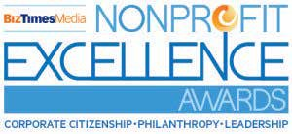
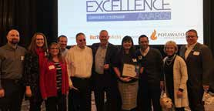
Beyond Vision named Social Enterprise of the Year
The BizTimes Nonprofit Excellence Awards honor nonprofits making an impact in Wisconsin. This award recognizes a nonprofit organization that demonstrates creative application of the principles of social enterprise in their operation and funding.

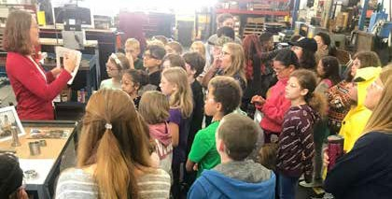
Events and Tours
To increase awareness and understanding of our mission within the community,
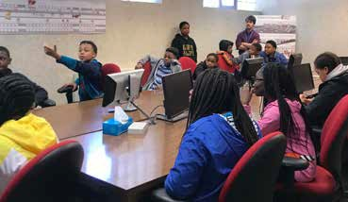
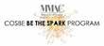
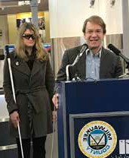
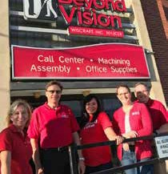
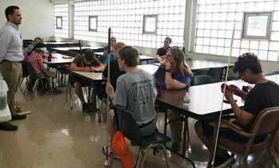
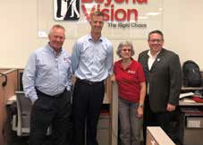
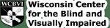
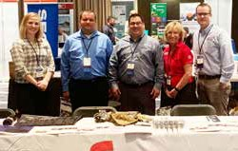
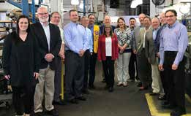
we participate in activities and host many opportunities to visit Beyond Vision

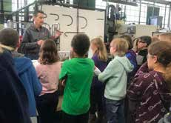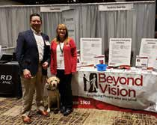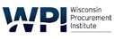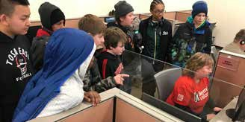

Thank You 2018-2019 Donors

INDIVIDUALS
Jose Acevado Ann Adkins Peter Adkins Roger Adkins
Dino Antonopoulos Thomas & Diane
Arenberg
Cliff & Janie Asmuth
Jean Avery Mike Banach
Michael Barber & Jackie Herd-Barber Kevin Barbour
Lukas Baumann Brian Beaumier Scott Beglinger Lee Beitzel Todd Bentley Casey Berrall Gordy Bradley Chris Brannin Garrett Brigman Steve Bruno Dan Brunow Steve Brunow Janet Buettner Mike Buettner Rob Buettner Ron Buettner Cindy Buss
Joe Carollo Natalie Cerfus Al Cervero Robbin Cervero Brian Clausen Adam Connor Kristin Cotter Ed Couillard Kristin Cox
Pat Crain Patty Crain Lisa Croatt Wayne Croatt
Danielle Cruise Matt Cruise Jillian Cullver Pat Czaplewski Steve D’Amato Carrie Davidson Matt Davies Mike Davis
Paul Dawson Brian Dean Paul Decoster Bob Delgadillo
Trent Denlinger Jerry DeQuardo Tim Desmond John Donovan Andy Dressing Dick Dubiak Linda Dubiak Shawn Duffy Matt Dutton Brian Dwyer Charlene Dwyer Kevin Dwyer John Emanuel & Wendy Moeller Thomas Enters Justin Erdamnn
Bernard Erenberger, Jr.
Luke Esslinger Gordon & Anne Farr Lisa Farr-Chowanek Jake Feeley
John Feeley Joseph Fenceroy Noah Fenceroy Steve Ferguson Art Flater LeAnne Foster Bridget Fritz Horace Gant
Fred & Anne Geilfuss Frank Gimbel
Matt Glassel Patty Gobin Gary Goyke Tim Granitz Mary Gross
Michael Gryczka Ryan Guilette Ric Guthrie
Guy Gutsche Mike Hacker Tom Hagen Blake Hammel Linda Hapka Jason Harper Mike Harpster Greg Hart Tyler Hart David Haugh Steve Heberer
Aaron Heidersheid Nick Hernke James Hofmann Steve Hubacek Kurt Huemmer
William & Patty
Hughes
Patrick Hutchinson Duncan Isbister Eric Isbister
Mary Isbister Danita Jackson Nick Jahnke Tom Kastroy Tyler Kelly Andy Kerlin Bill Kerlin Cynthia Kerlin Drew Kerlin
James & Shawn
Kerlin Jeff Kerlin Neal Kerlin
Alex Kihslinger Paul Kihslinger Lisa Kratcha Conner Laabs Tim Lamm Christa Lange CJ Lange Mary LaPointe
Stewart LaPointe Bob Leppanen Harry Lewis Cindy Linnan
Pat Linnan Deb Lucas Jeff Lucas
Billy MacDonald John Maggio Michelle Martinson Dave Mayo
Brian McNanny Amy Meier Burton Metz Adam Meyer Robin Mickler Mike Miller Mike Moennig Austin Moore Bridget Moore Mike Moore Paula Moore Ronald Morey Ashley Mueller Chris Mullen Eileen Murphy Ryan Muzik Paul & Cynthia Muzzey
Ryan Namey
Meghan Neimon Deb Nelson Angela Newman Mike Newman Joe Obligato
Jeff Olson Anthony Otto Cindy Pagenkopf Kevin Pagenkopf Jessica Parsons George Patterson Joe Paulus
Kevin Peters Pat Pfersch Luc Piessens Cindy Pinkley Henry Pinkos Pat Pinkos Julie Potnek Chris Powers Jakob Powers Jeff Powers Mike Proctor Jason Putnam Mike Quill Kevin Rigg
Kevin Riordan & Martha Johnson Ruben Rodriguez Bobbi Ruston Doug Ruston Chris Ruud
Matt Schendel Thomas Schiesl Brigitte Schmoll Scott Schultz Carl Schumacher
Eric & Jane Schumann Peter Schwabe
Nick Scott
John & Nancy Sennett
Bryan Severner Sid Sidebotham Lynn Sigfred
Liz Smith Mike Smith Tom Smith Paul Spencer
Bob Stachowiak
John Stibal
Tracey Strombeck Kedrick Strutz Nate Suelflow Abby Tanner
Dick Theado
Sharon Thompson Ken Tibbits
Steve Ticcioni Joyce Tomkowiak Joe Torsiello Juliet Urso
William & Barbara Velez
Aina Vilumsons James & Yong Voigt DiAnna Vouvakis Emmanuel Vouvakis Monica Waddington Jack Walden
Jamison & Jessica Walton Arthur Wasserman Shane Weiske
Nicholas Wergin Chuck Wikenhauser Trish Wikenhauser Dan Wilkens
Aaron Winkler Tom Wojcinski Alejandro Zamoea Jim Ziebart
Kristin Ziebart Thomas Ziety

ORGANIZATIONS
3M
Amazon Smile Foundation
American Transmission Company
Associated Industries for the Blind
AW Asmuth Family Fund Bader Philanthropies, Inc Badger Meter Foundation Inc. Bartolotta Catering
Becher Development Belleville Boot Company Bellile Family Trust Boerke Company Bostik, Inc
Bradley Impact Fund
Briggs & Stratton Corporation Briggs & Stratton Foundation Capital Investment Services of
America
Chrysalis Packaging
City of Milwaukee CDBG Cognex Corporation
Crown Mats Cudahy Lions Club Dawes Crane Rental
Dorothy Inbush Foundation
Dr Harry J Heeb Foundation Duffy Grain
Essendant
Forest County Potawatomi Foundation
GE Foundation GenMet
Green Bay Packers Foundation
Harley Davidson Foundation Kettle Moraine Lions Club Hartford Lions Club
HD Supply
Helmut Wolfgang Schumann
Foundation
Husch Blackwell LLP IBVI Milwaukee JayKay Foundation
Kimpton Journeyman Hotel
King Innovative LLC Kohl's Corporation Legacy Capital Partners Lions Clubs of Wisconsin
Marcus Hotels and Resorts Margaret Wiegand Trust Milwaukee Bucks
National Business Furniture National Exchange
Bank & Trust
National Industries for the
Blind
Newburg Lions Club Pabst Theater Group Park Bank Foundation Patrick and Anna M.
Cudahy Fund
Public Service Commission
of Wisconsin
Robertson Ryan &
Associates
Saz's Catering Inc Silver Spring Golf Club
Stackner Family Foundation The Gardner Foundation The Greater Milwaukee
Foundation
Thomas J Reinhart
Foundation
Uline
Vision Forward Association Walter Lindsay Foundation Waukesha Lions Club
WE Energies Foundation Wipfli

Beyond Vision | 414-778-5800 | 5316 West State Street, Milwaukee, WI 53208 | www.beyondvision.com
To Donate - Contact Nick Czaplewski - nczaplewski@beyond-vision.org

